**ASIAN COLLEGE OF HIGHER STUDIES**

**(Affiliated to Tribhuvan University)**

**Ekantakuna, Kathmandu**



**LAB REPORT**

**OF**

**“Operating System”**

**Submitted by**

**Shradha Khatiwada (211843)**

**Fourth Semester**

**Submitted to**

**Birendra Yadav**

**ACHS, Lalitpur**

# Basic Linux Commands

## clear:

Interpretation: Clears the content of the screen.

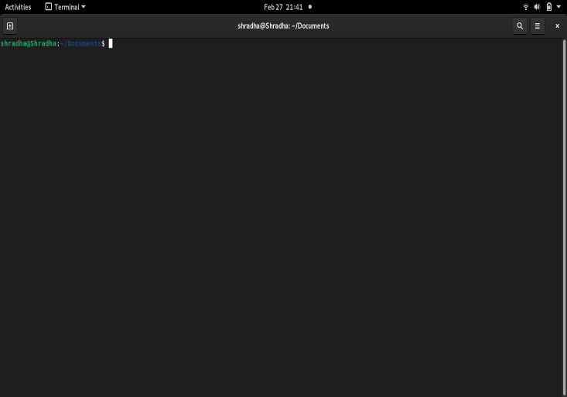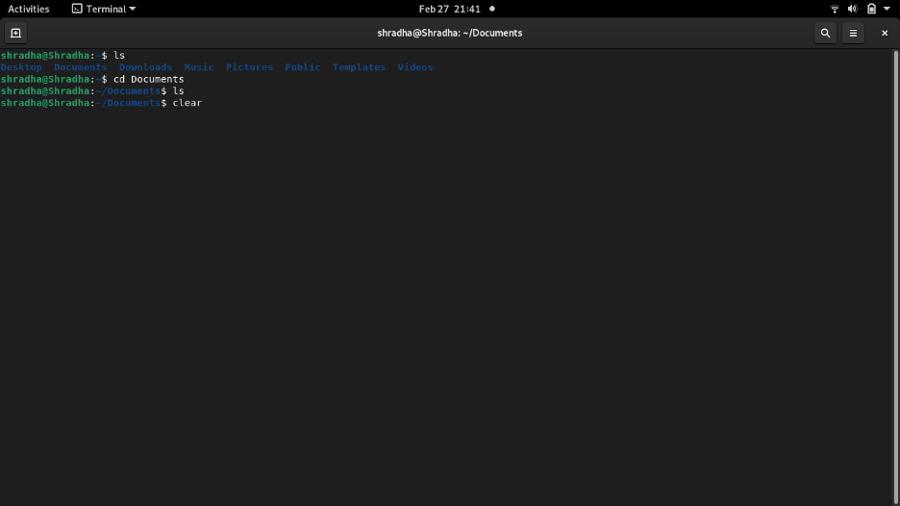Output:

## ls:

Interpretation: Returns the list of all the files and folders in the current working directory.

Command: ls

Output:

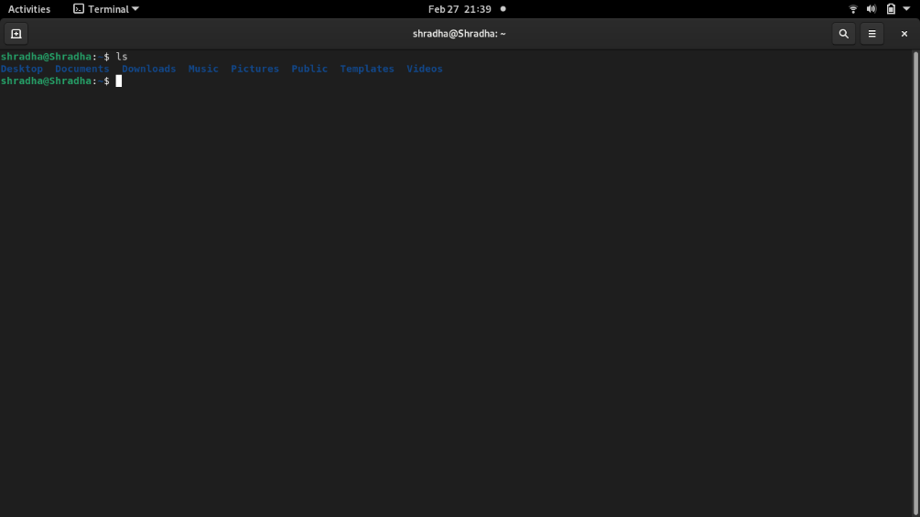

## ls --help:

Interpretation: Displays all the possible commands related to ls.

Command: ls --help

Output:

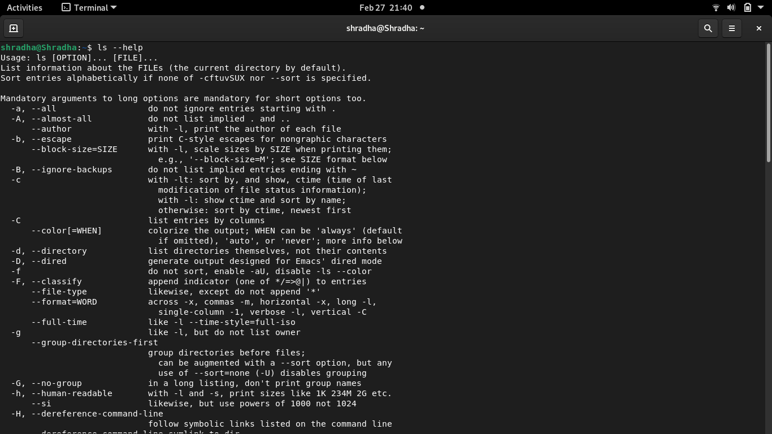

## cd:

Interpretation: Changes working directory to root directory.

Command: cd

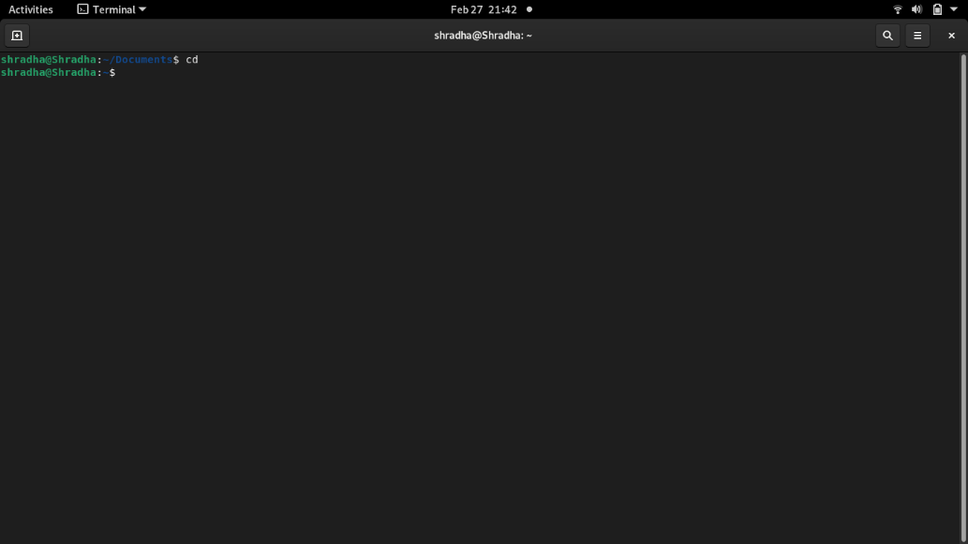Output:

## cd ..

Interpretation: Changes working directory to the parent of current directory.

Command: cd ..

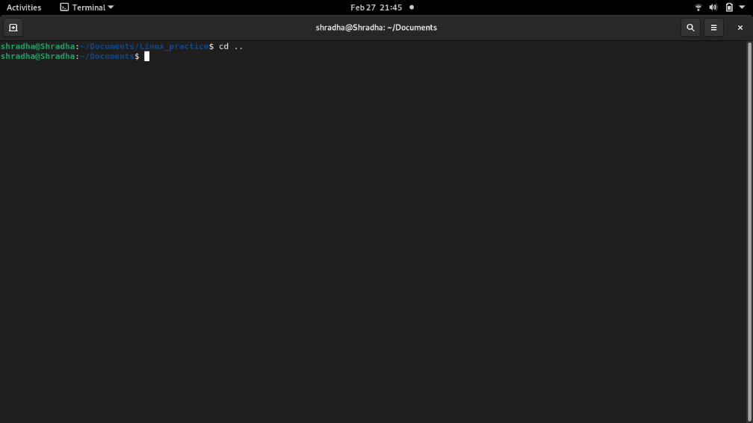Output:

## cd <path>

Interpretation: Changes working directory to the specified path if it exists.

Command: cd “/media/aashish/New Volume”

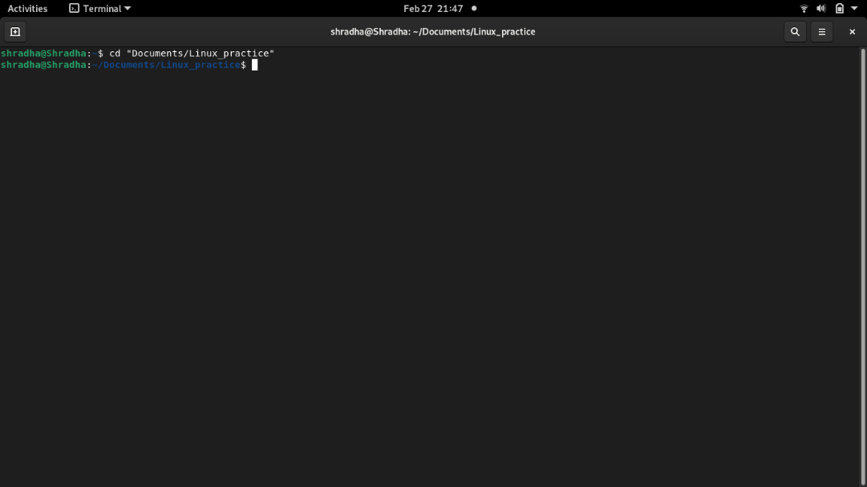Output:

## mkdir:

Interpretation: Creates a folder in the current working directory.

Command: mkdir Linux

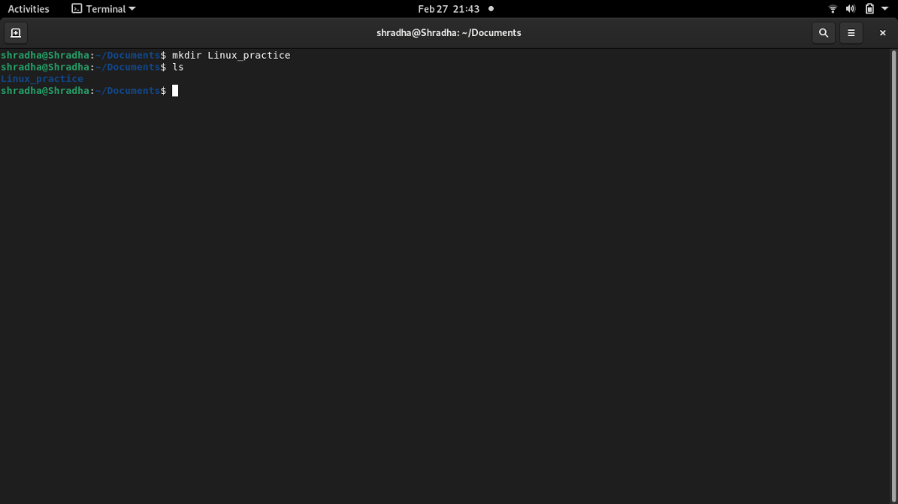Output:

## touch:

Interpretation: create file with the specified extension.

Command: touch filename.ext

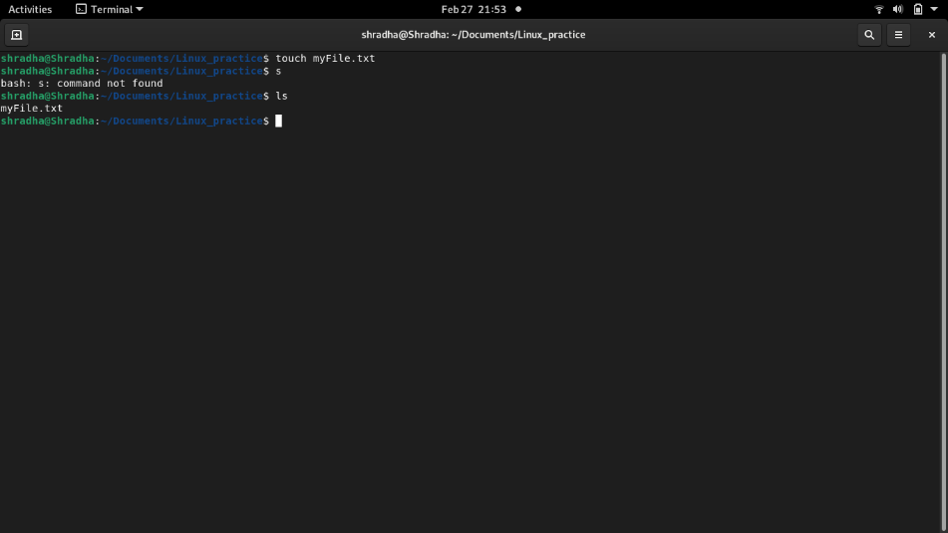Output:

## cat:

Interpretation: Accepts text from input stream and writes to the file. The user need to write text and press Ctrl + D to write the texts into the file.

Command: cat > filename.ext

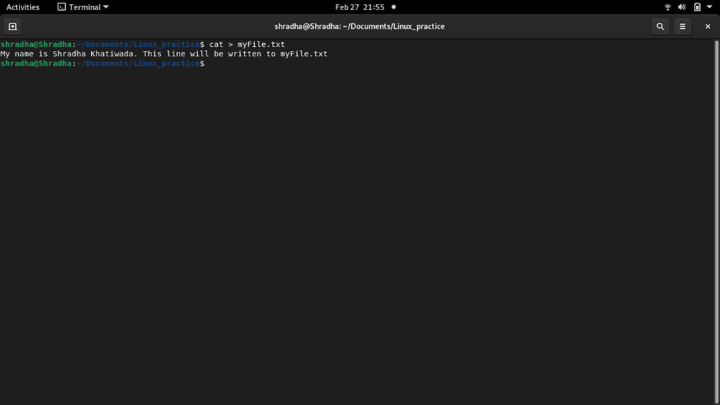Output:

## rm:

Interpretation: Remove files from current working directory.

Command: rm filename.ext

Output:

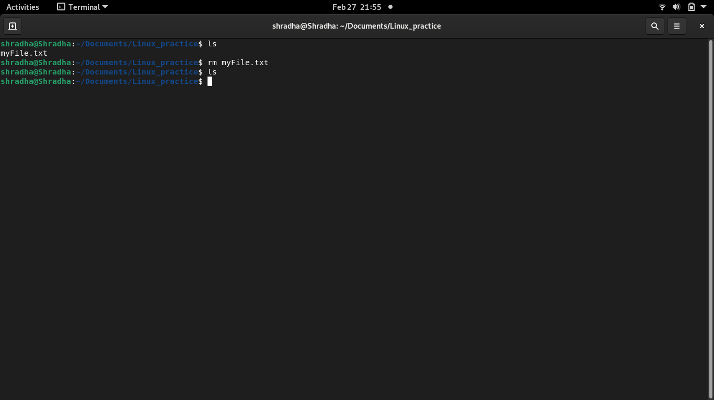

## rm –rf:

Interpretation: Removes folder forcefully from the current working directory even if it contains any files and/or subdir.

Command: rm –rf folderName

Output:

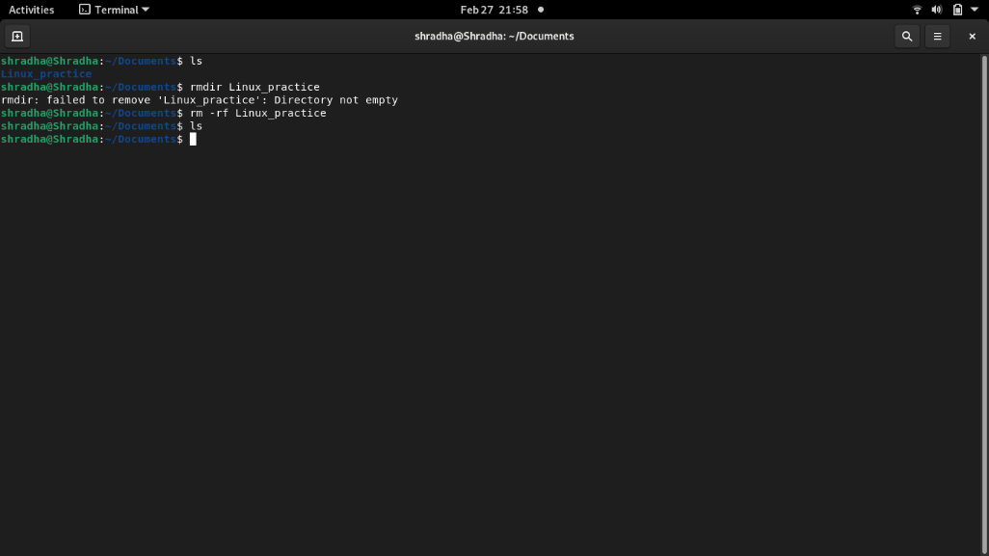

## rmdir:

Interpretation: removes specified directory from current working directory.

Command: rmdir foldername

Output:

